Alchemy Business Broker Support:

At Alchemy Performance Partners, we provide business brokers with a unique, competitive advantage – whether assisting their client sell their small business or helping potential buyers purchase the small business of their dreams.

Our typical process for helping a Broker support the business Seller:

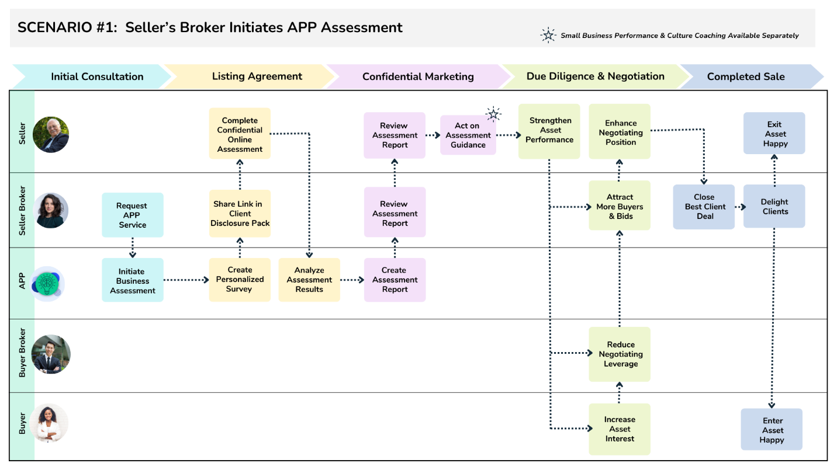

Broker and Seller advantages:
- Assists the Seller maximize performance in prep of potential sale;
- Helps Broker manage Seller price point expectations;
- Augments the traditional, financial valuation with organizational performance strengths and gaps to close;
- Solidifies asking price justification and negotiations stance;
- High performing asset attracts greater Buyer interest and competitive bidding;
- Assists in managing the uncertainty and distraction for the organization introduced during marketing and sale period; and
- High performing asset reduces Buyer Broker’s negotiating leverage.

