Alchemy Business Broker Support:

At Alchemy Performance Partners, we provide business brokers with a unique, competitive advantage – whether assisting their client sell their small business or helping potential buyers purchase the small business of their dreams.

Our typical process for helping a Broker support the business Buyer:

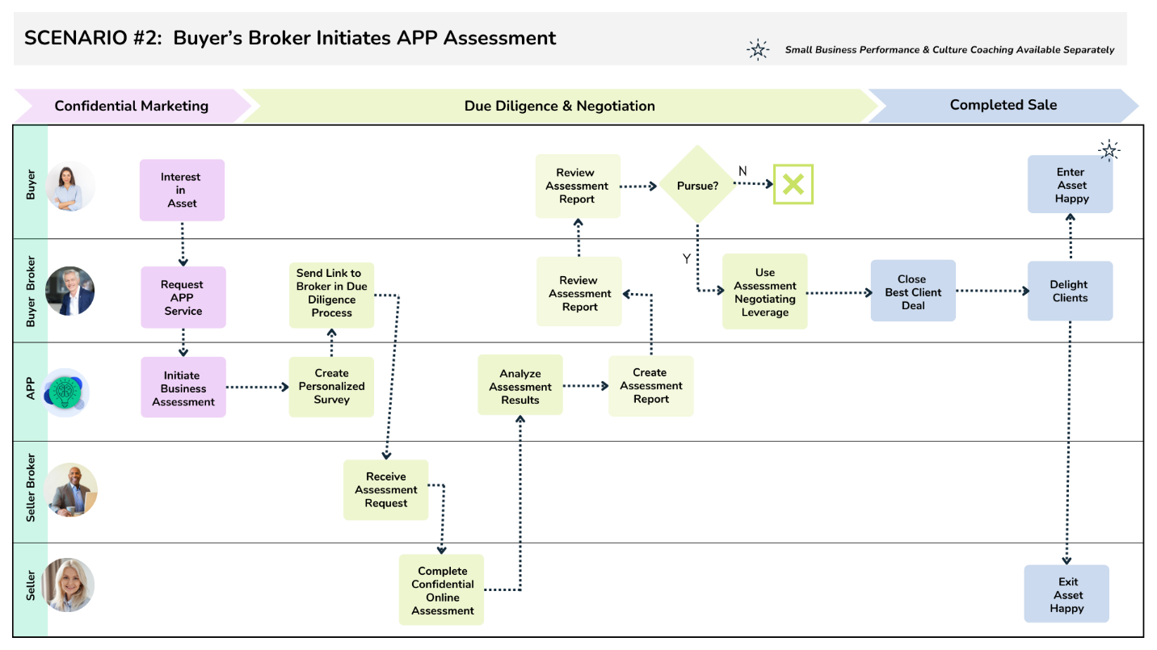

Broker and Buyer advantages:
- Assists the Buyer understand the actual performance and potential value of the asset prior to negotiations;
- Allows for quick determination of business fit for the Buyer, saving resources;
- Supplements the traditional, financial valuation with organizational performance strengths and gaps to close;
- Fortifies Buyer offer price and negotiations stance; and
- Provides Buyer with an optimized business model and management plan to maximize ROI immediately upon asset purchase

